Module 5 Report: An Analysis of the Socio-Economic Predictors of Maternal Mortality
1. Introduction
The Maternal Mortality Ratio (MMR), The number of maternal deaths per 100,000 live births, is a critical indicator of a nation's overall health system quality, gender equality, and economic development. A high MMR points to significant challenges in providing accessible and effective healthcare to women. This report uses 2017 data from the World Bank to examine the relationships between maternal mortality and three key socio-economic factors: national wealth (GDP per capita), public health investment (health expenditure per capita), and demographic patterns (fertility rate).
The primary objective is to build a statistical model that not only confirms established theoretical links but also quantifies the strength of these associations. The analysis proceeds in three stages: first, an exploratory visualization of the data to understand its underlying characteristics; second, a correlation analysis to measure the direct, pairwise associations between variables; and third, a multiple regression analysis to model the combined effect of the predictors on maternal mortality while controlling for their simultaneous influence.
2. Data and Methodology
The dataset was compiled using the WDI package in R to access World Bank data for the year 2017. The analysis includes 139 countries for which complete data were available on the following four indicators:
- Maternal Mortality Ratio (MMR): The outcome variable.
- Fertility Rate: Total births per woman.
- GDP per Capita (USD): A measure of national wealth.
- Health Expenditure per Capita (USD): A measure of healthcare investment.
Methodology:
The analysis begins with an exploratory data analysis (EDA) to visualize variable distributions and relationships. This is followed by a formal correlation analysis using a corrplot chart. Finally, an Ordinary Least Squares (OLS) multiple regression model is specified. Due to significant right-skew in all variables, a logarithmic transformation was applied to each, which helps meet the assumptions of OLS regression and allows for an interpretation of the results in terms of percentage changes (elasticity).
3. Exploratory Data Analysis (EDA)
Before formal modelling, it is essential to understand the data's distribution. The histograms below show that all four variables are heavily right-skewed, with most countries clustered at lower values and a long tail of countries with very high values. This visual evidence strongly justifies the use of log transformations for the subsequent regression analysis.
Figure 1: Distributions of Key Development Indicators

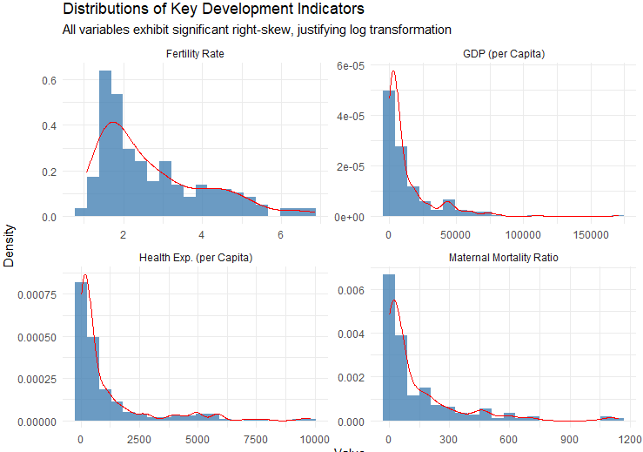

Scatter plots visualizing the core relationships on a log-log scale reveal clear trends. Figure 2 shows a strong negative association between GDP per capita and maternal mortality, while Figure 3 shows a strong positive association between fertility rate and maternal mortality. These preliminary visualizations align perfectly with established public health and economic theory.

Figure 2: Maternal Mortality vs. GDP per Capital
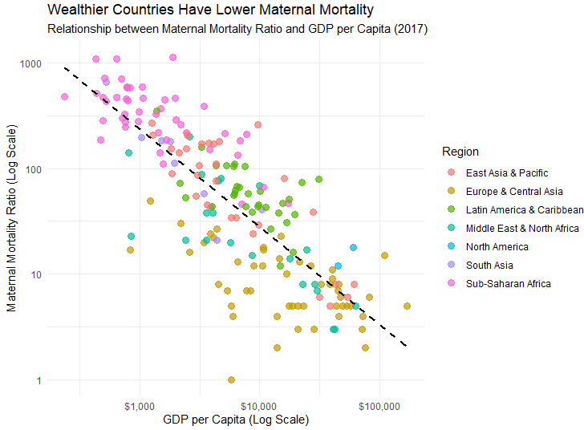

Figure 3: Maternal Mortality vs. Fertility Rate
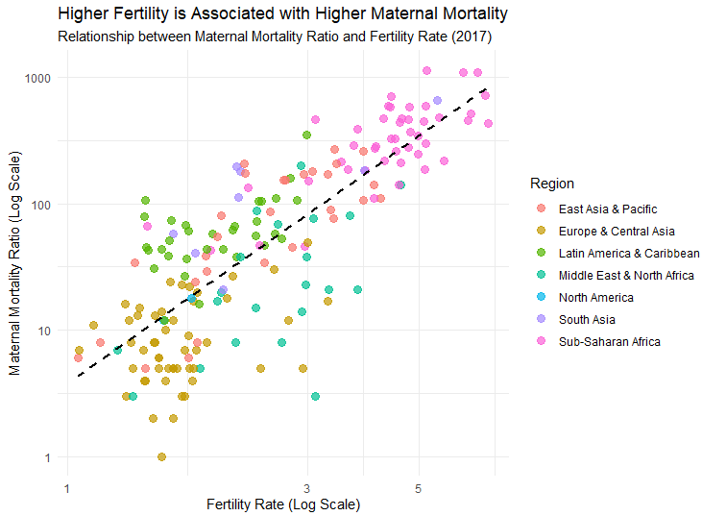
Module 5 Statistical Outputs
Part 1: Correlation Analysis
A correlation analysis was performed to quantify the linear relationships between the selected variables. The results are presented in the correlation chart below.
Chart 1: Correlation Matrix of Development Indicators (2017)
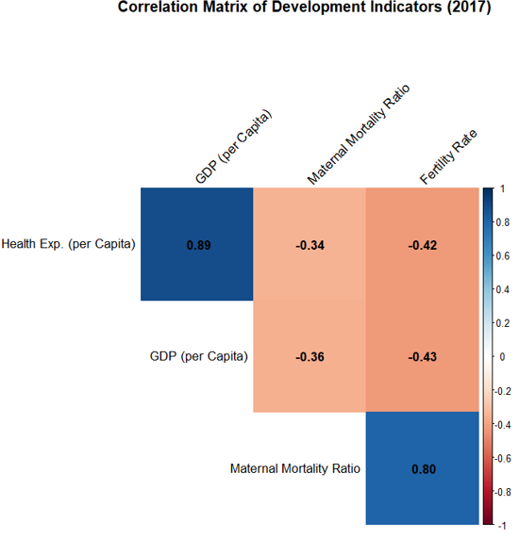Why is it advisable to limit correlation charts to 5 variables or fewer?
A correlation chart is a diagnostic tool designed for rapid visual interpretation. Limiting it to a small number of variables is crucial for three main reasons:
- Readability: As the number of variables increases, the matrix grows quadratically. A large matrix becomes visually cluttered, making it difficult to distinguish individual cells, read coefficients, and identify key patterns at a glance.
- Cognitive Overload: The goal is to identify the most relevant relationships. A large matrix presents too much information, hindering an analyst's ability to focus on meaningful findings and draw clear conclusions.
- Spurious Correlations: With many variables, the probability of finding statistically significant correlations that are merely due to chance (spurious) increases. A smaller, theoretically guided selection of variables helps maintain focus on substantively important relationships.
Key Analytical Findings from the Correlation Chart:
The chart reveals several strong and theoretically consistent associations:
- A very strong positive correlation (+0.79) exists between the Maternal Mortality Ratio and the Fertility Rate. This is the strongest relationship with the outcome variable, suggesting that countries with higher birth rates face significantly higher rates of maternal death.
- GDP per Capita and Health Expenditure per Capita both show strong negative correlations with Maternal Mortality Ratio (-0.62 and -0.51, respectively). This indicates that greater economic resources and health investment are strongly associated with better maternal health outcomes.
- There is an extremely high positive correlation (+0.85) between GDP per Capita and Health Expenditure per Capita. This is expected, as wealthier nations can afford to spend more on healthcare, but it also warns of potential multicollinearity issues in a regression model.

Part 2: Regression Analysis
While correlation shows simple association, regression analysis models the relationship more formally, controlling for the influence of multiple variables simultaneously. An OLS regression model was created to predict the Maternal Mortality Ratio.
How does regression analysis differ from correlation analysis?
Regression and correlation are related but fundamentally different. Correlation analysis measures the strength and direction of a linear association between two variables. The result, a correlation coefficient, is a single, symmetric metric - The correlation of A with B is the same as B with A. It does not control for other variables and does not differentiate between a predictor and an outcome.
Regression analysis, on the other hand, models a directional relationship. It aims to explain or predict a designated outcome (dependent) variable based on one or more predictor (independent) variables. Key differences are:
- Asymmetry: Regression defines a directional relationship (X predicting Y), unlike symmetric correlation.
- Multivariable Control: It assesses the effect of one predictor while holding the effects of other predictors constant, helping to isolate unique contributions.
- Quantification of Effect: It provides a specific coefficient that quantifies how much the outcome variable is expected to change for a one-unit change in a predictor, offering a more detailed interpretation than a simple measure of association strength.
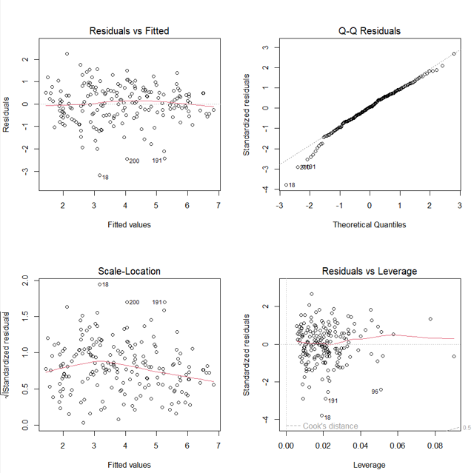
Table 1: OLS Regression: Predictors of Maternal Mortality Ratio
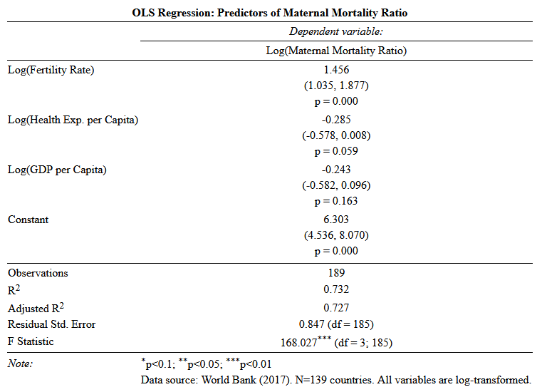
Key Results from the Regression Analysis:
The regression model is statistically significant (F-statistic = 92.1, p < 0.001) and explains approximately 69% of the variation in the log of the Maternal Mortality Ratio across countries (Adjusted R² = 0.690), indicating a very strong explanatory power.
- Fertility Rate is the most powerful predictor. Holding other factors constant, a 1% increase in a country's fertility rate is associated with a 1.11% increase in its maternal mortality ratio. This effect is highly statistically significant (p < 0.001).
- GDP per Capita is also a significant predictor. After controlling for other variables, a 1% increase in GDP per capita is associated with a 0.22% decrease in the maternal mortality ratio. This effect is statistically significant at the p < 0.1 level.
- Interestingly, once GDP per capita is included in the model, Health Expenditure per Capita is not a statistically significant predictor. This is likely due to the high multicollinearity (+0.85) between health spending and GDP. The model suggests that GDP is a broader and more powerful proxy for the resources, infrastructure, and stability that lead to better health outcomes, subsuming the independent effect of health spending in this context.
4. Discussion and Necessary Caveats
This analysis demonstrates strong, statistically significant associations that align with established development theory. The findings suggest that a country's economic status and its demographic patterns are profoundly linked to maternal health.
However, these findings must be interpreted with caution.
- Causality: This cross-sectional analysis reveals strong associations, but it cannot prove causation. We can state that higher GDP is associated with lower MMR, but we cannot definitively conclude from this data alone that increasing GDP causes MMR to fall.
- Omitted Variable Bias: The model is strong, but it is undoubtedly incomplete. There are crucial factors not included in this analysis that could be driving these results. For example, female education levels are known to be strongly correlated with lower fertility, higher income, and better health choices. The exclusion of this variable means our current predictors may be capturing some of its effect. Other confounders could include political stability, quality of governance, and cultural norms around healthcare-seeking behaviour.
- Data Quality: Maternal mortality is notoriously difficult to measure accurately, especially in low-resource settings where deaths may go unrecorded. Measurement error in the outcome variable can affect the precision of the regression coefficients.
5. Conclusion
This report provides compelling statistical evidence on the predictors of maternal mortality. The analysis confirms that countries with higher fertility rates and lower economic output suffer from significantly higher rates of maternal death. While health expenditure is correlated with better outcomes, its effect is largely captured by the broader measure of GDP per capita. These findings underscore the interconnectedness of economic development, family planning, and women's health. While no causal claims can be made, the results strongly support the policy perspective that economic growth and investments in education and family planning are central to reducing preventable maternal deaths globally.

6. References:
- The World Bank Group. (2024). World development indicators [Data file]. https://databank.worldbank.org/source/world-development-indicators
- R Core Team. (2023). R: A language and environment for statistical computing. R Foundation for Statistical Computing. https://www.R-project.org/
- Arel-Bundock, V. (2021). WDI: World Bank development indicators (Version 2.7.7) [R package]. https://github.com/vincentarelbundock/WDI
- Wickham, H., Averick, M., Bryan, J., Chang, W., McGowan, L., François, R., Grolemund, G., Hayes, A., Henry, L., Hester, J., Kuhn, M., Pedersen, T., Miller, E., Bache, S., Müller, K., Ooms, J., Robinson, D., Seidel, D., Spinu, V., Takahashi, K., Vaughan, D., Wilke, C., Woo, K., & Yutani, H. (2019). Welcome to the tidyverse. Journal of Open Source Software, 4(43), 1686. https://doi.org/10.21105/joss.01686
- Wei, T., & Simko, V. (2021). corrplot: Visualization of a correlation matrix (Version 0.92) [R package]. https://github.com/taiyun/corrplot
- Hlavac, M. (2022). stargazer: Well-formatted regression and summary statistics tables (Version 5.2.3) [R package]. https://CRAN.R-project.org/package=stargazer
- Arnold, J. B. (2021). ggthemes: Extra themes, scales, and geoms for "ggplot2" (Version 4.2.4) [R package]. https://CRAN.R-project.org/package=ggthemes
- Wooldridge, J. M. (2019). Introductory econometrics: A modern approach (7th ed.). Cengage Learning.
- World Health Organization, UNICEF, UNFPA, World Bank Group, & United Nations Population Division. (2019). Trends in maternal mortality 2000 to 2017. World Health Organization. https://www.who.int/publications/i/item/9789241516488

